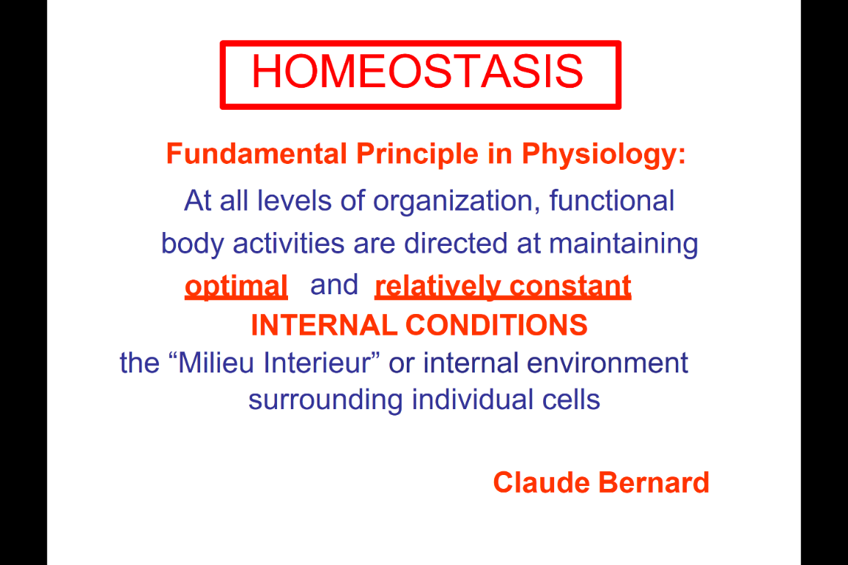
- GIT (gut, digestive track)
- Accessories of GIT track
- The textbook reading ch15, there will be difference. (Same information , read it )
- Responsible for the lectures
- Homeostasis –maintain constant internal condition, all the body system is to maintain this.
- The Homeostasis is what give us help, the break down will give pathology/disease

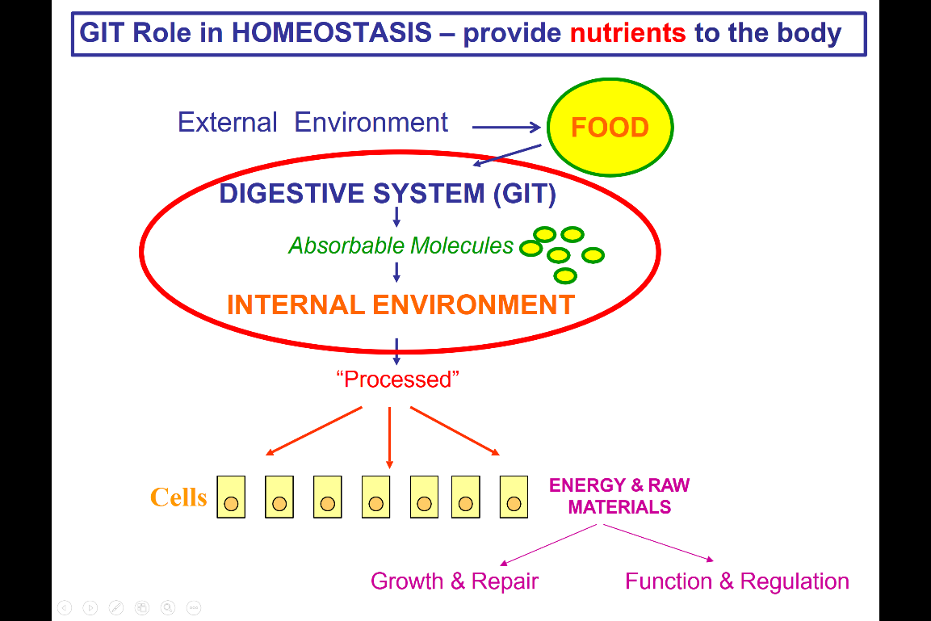
- The role og GIT homeostasis : give nutrient to the body
- Food from external environment, GIT will break down the component in to absorbable molecule and transform into the blood stream, interstitial fluid (this is useful for all the cells in body)
- The break down of component, so they can enter the internal environment.
- When get to this stage we said the food has been process
- At this stage it can be move to blood stream to be delivered to every cell in the body
- At the cell, it will be the energy of raw material for the cell to use in growth and repair, also the regulation.
- So the process of materials will goto all the cells to be energy materials for cell function.
- What we will talk about in 9 lectures, is what happen in red circle.
== >how the digestive system is going to process the food and go to the point that is a absorbable molecule for the body.

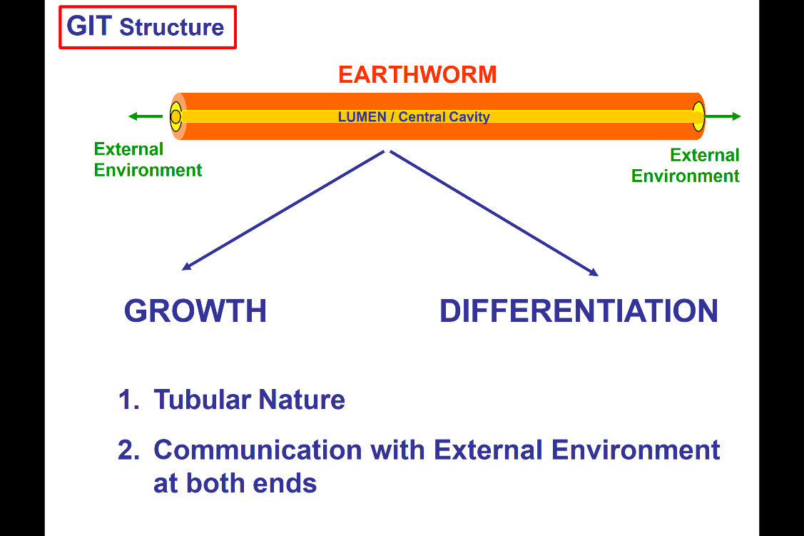
GIT:
- Earthworm have a very simple Gastrointestinal track
- A simple tube, central cavity (lumen)
- In earthworm. It is opened to external environment at both end of the GIT.
- In higher animals
- The simple tube has grown and differentiated
- The different length, and specialize function of the GIT
- Despite the fact the GIT track become more complicated in higher animals. It always maintain the tubular nature, and communicate at both ends to external.

- The size of GIT:
- The size of GIT is much larger than human individual.(Standard male: 1.5m, but mouth tp Anus is 4.5m --- many times of the size of human)
- What make the GIT?
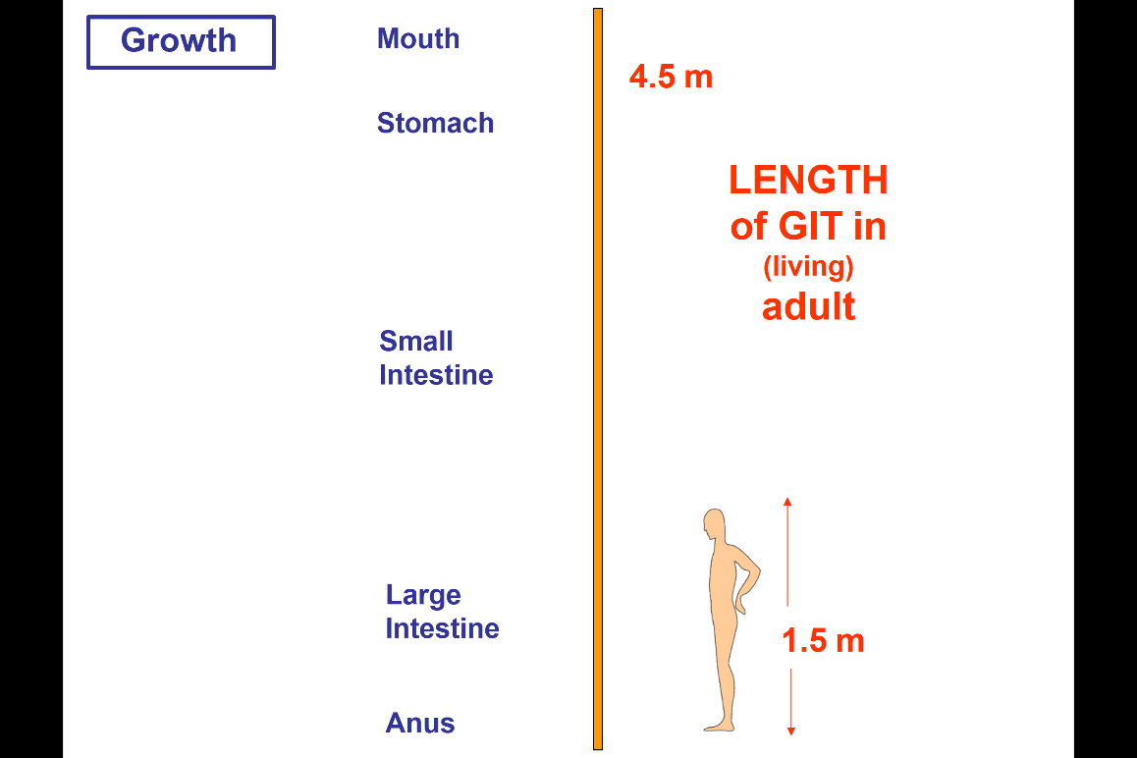
- How the GIT functions are serve by the enteric nervous system?
- If make a cross section through most of the GIT, we will see the similar tubular structure (Similar layers throughout the GIT track at all these different levels.

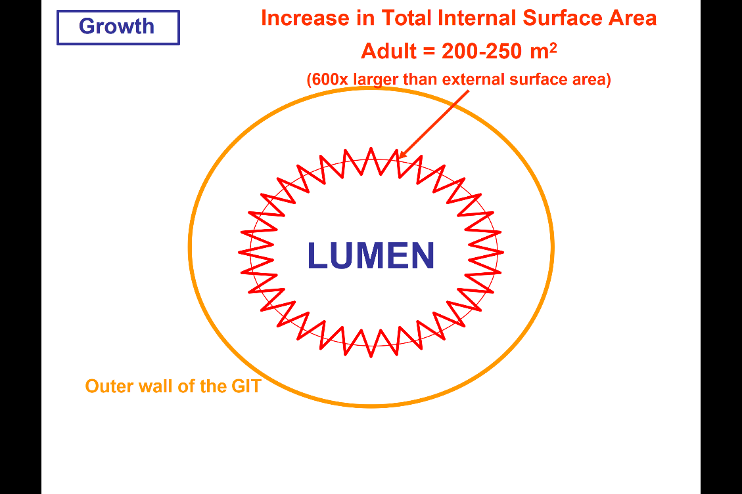

The outer wall of GIT
- Cross section: outer wall and inner lumen
- Lumen: the surface area is much greater than the external outer wall of the surface (600 times more surface area at the lumen level than at the outer wall.)
- Reason of the massive increase of surface area in the lumen, because this is the absorbance and secretion site (need many more cells to perform the function in GIT than in the external layer which is just to contain the gut itself.)
- So this specialization is very important
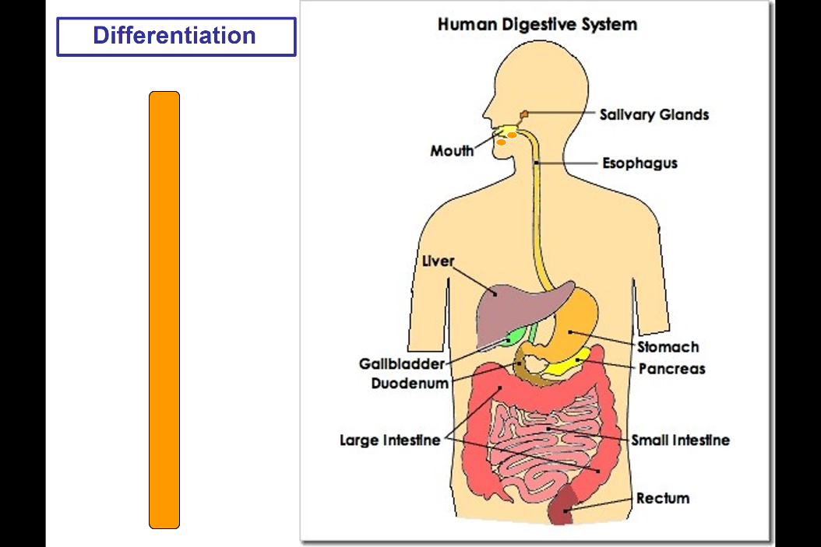

As in the more evolved animal, the differentiation of simple tubules have now with different accessories ….
In human:
- Mouth (contact with the external environment )
- Pharynx
- Esophagus
- Stomach
- Different component of the small intestine
- The large intestine
- Anus (In contact with the external environment)
Many accessories organs that are not part if the GIT, but contribute to the function of GIT track
- Salivary glands
- liver
- gallbladder
- pancreas
- all these secrete things to GIT track that will contribute importance function
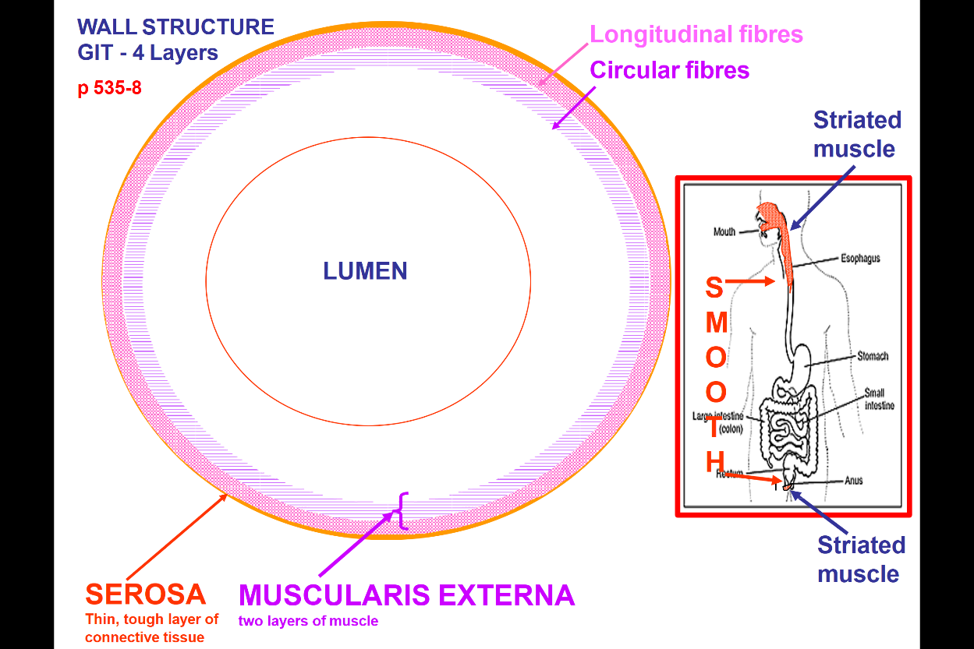

- the wall structure.
- 4 main layers
- Outer layers : the tough connective tissue: serosa
- Muscularis externa: 2 layers of muscle
- Outermost: longitudinal fibers ( running along the tube length , if muscle contract it will shorten.)
- Interior layers : circular fibers (around the diameter of tube, if contract the circumference of the tract will decrease. )
- These two have specific functions in either break down and movement of food. (So two different type is important with different arrangement.)
- Another thing about the muscle, is that it is not all the same throughout the length of GIT.
- If you take a cross section from the upper part of GIT (mouth, upper 1/3 of esophagus) and the lower part( the part that bellow the anal sphincter) , we will see the muscle is striated muscle. (The rest is smooth muscle)
- Submucosa – a layer of loose CT and vessels, lymphatic going through…
- Interior of submucosa is the mucosa (next slide)

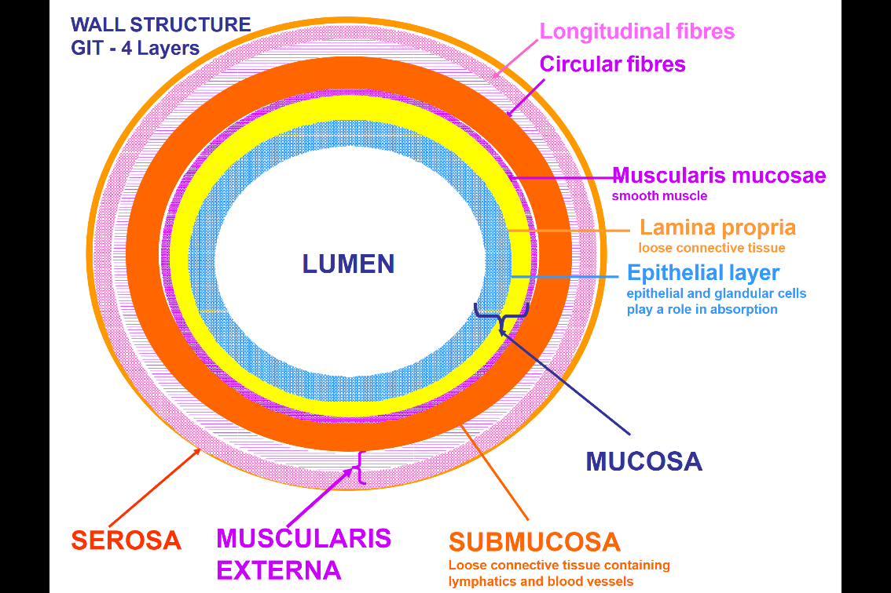

The mucosa is made up of 3 layers
- MUSCULARIS MUCOSA ----smooth muscle cells
- Lamina propria --- connective tissue with fibers running through
- Epithelial layer --- contact with the content of GIT track (make up of epithelial cells and secretory cells ---allow secretions into the GIT track, into the blood stream and also the absorption of the nutrients. ) The epithelial layer is a very important layer

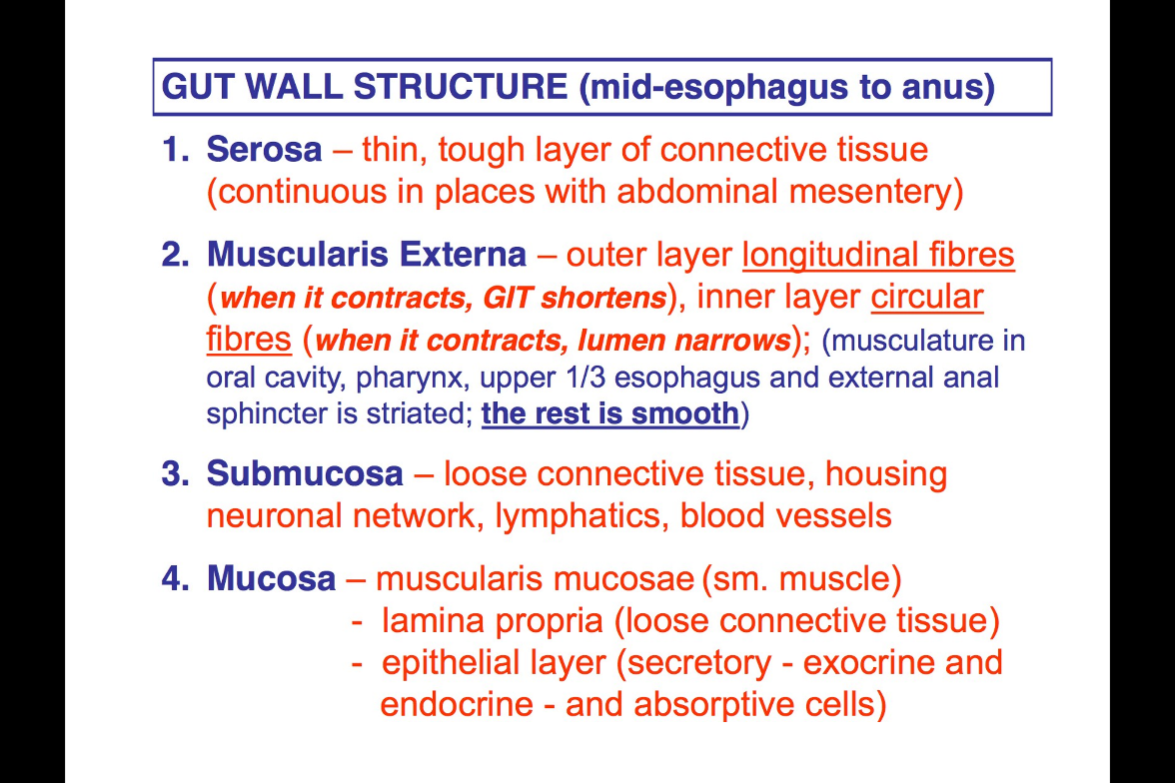
- Serosa: abdominal mesentery is what keep the GIT in place. Because the GIT is connected to the abdominal wall at different places along the abdominal mesentery.
- Muscularis Externa. This is the layer that different depends on the different GIT part.
- Top/bottom: striated fibers
- Other: smooth muscle fibers in 2 layers
- Submucosa
- Mucosa --- 3 different layers.

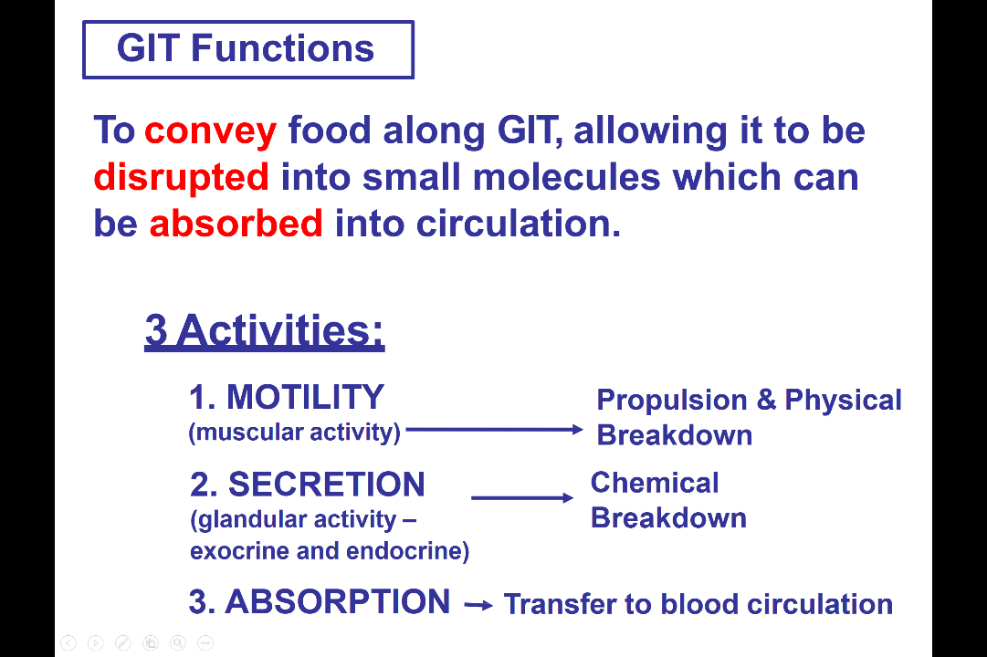
- Once absorb in circulation can be used by the cell body.
- 3 main activities
- Motility: move things along the GIT --- propulsion and physical break down of the food
- Secretion: glandular activity ( both exocrine(release the substance to the cell itself) and endocrine (release the substance that join the blood stream and affect at the larger range) ) --- chemical break down of the food
- Absorption: Transfer of molecule to blood circulation
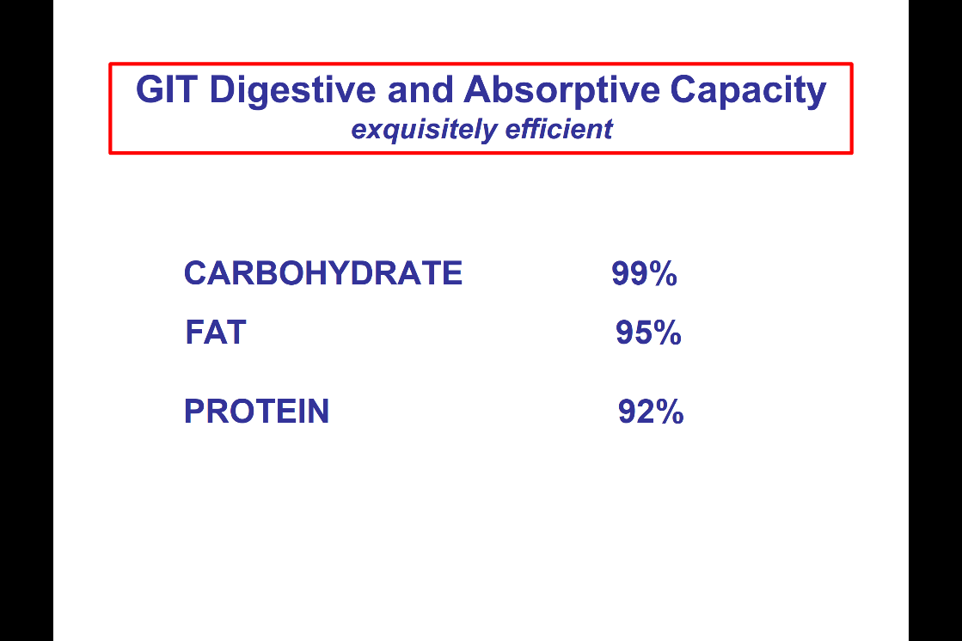

- The great amount of surface area contribute to the efficient absorption capacity.
- Because of the structure, we almost absorb everything that we eat.
- The gut is not making decision whether we need the nutrient or not, it jobs is just to break down the food and absorb the food. – highly efficient

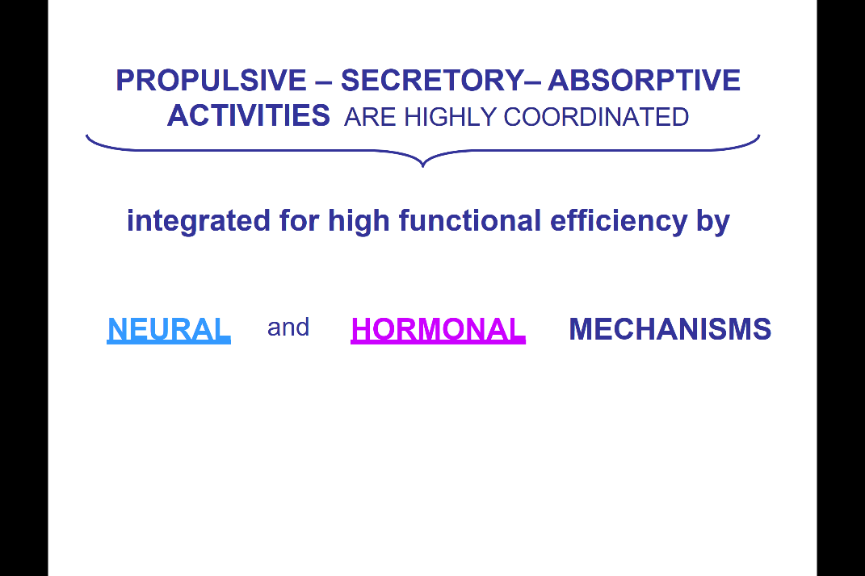

Than the gut - propulsion (muscular to act propulsive activity), secretory, absorptive activity
- All of these are highly coordinated and so we have the nervous system in GIT that is highly integrated for functional efficiency.
- Neural, Hormonal mechanism is highly coordinated in order to keep this functional GIT track running efficiently as possible

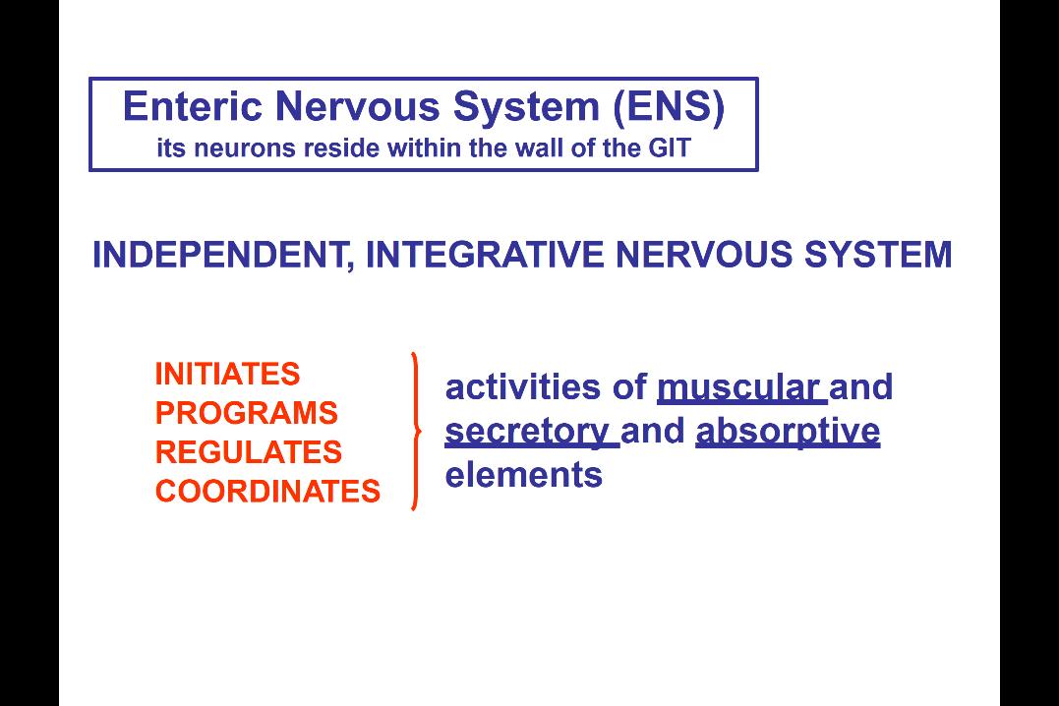
- The ENS reside with in the wall of the GIT
- ENS function independently: have all the elements that are necessary to operate independent of the central nervous system. – sensory fibers , excitory , inhibitory fibers and interneuron that allow the very coordinated response within the Enteric nervous system just within the gut wall itself. (so it doesn’t need input form the CNS to operate , it has all the component in the wall of Gut to function, and it is highly coordinated)
- Independent, Integrated, highly coordinated, with interneuron that send signal from one part of the gut through the gut wall to another part of the gut. (It will be able to integrate over distance as well as layers)
- Initiate, program, regulate, coordinate activity (everything is needed are all present within the GIT wall) – for activity of muscular, secretory , absorptive

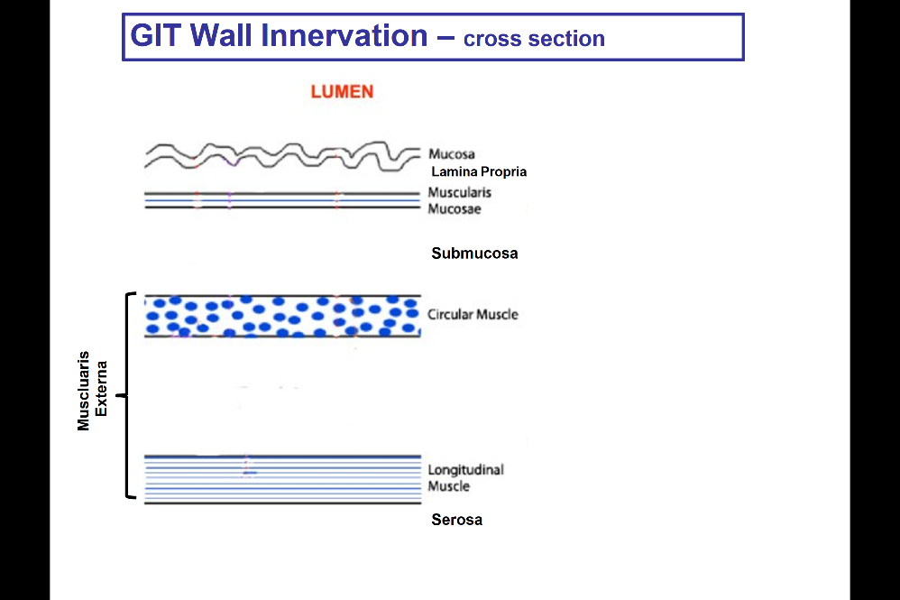

Top is the lumen, cross section.
- We break down the layers (so spaces I between, to see the enteric nervous system is situated within the gut wall.)

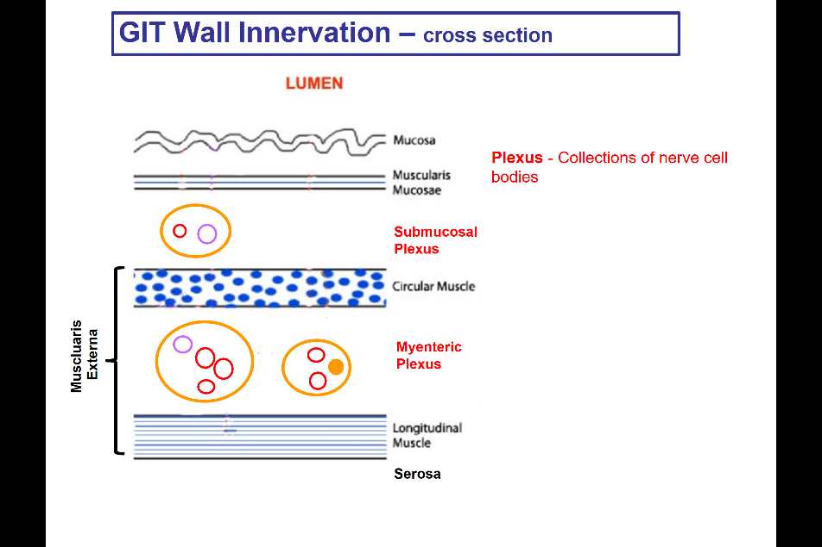
Within the myenteric plexus (between two muscle layers) and Submucosal plexus (within submucosa loose CT) , (the plexus is just collection of cell bodies)
- Submucosal plexus will most affect the muscosal layers
- myenteric plexus will most affect the muscular layers
- we lump them together and talk them as one functional unit
- the plexus contain all the elements to have a reflex arc

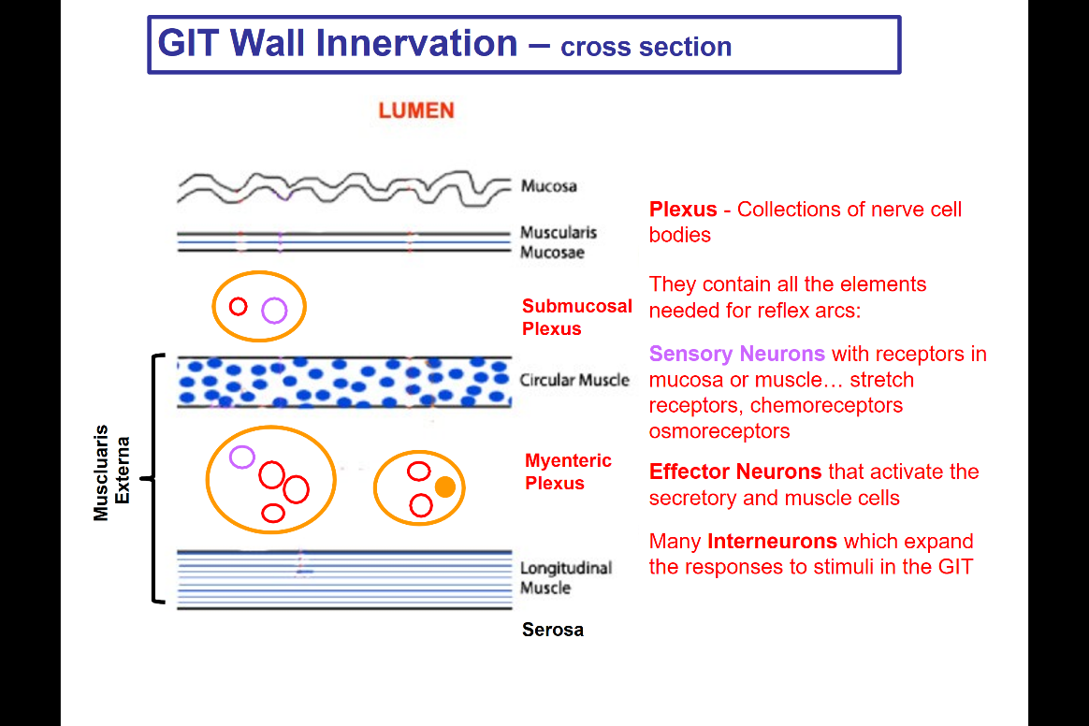

- the plexus contain all the elements to have a reflex arc
- sensory neurons which have receptors at the level of epithelium, to sense the content of the gut
- chemorecptor, osmoreceptor, these will tell us the contents of what is in the lumen .
- mechanical receptor at the muscularis layer (In circular and longitudinal) to tell the stretch of the gut.
- Effector neurons are the one that contact muscle cells and secretory cells and cause the m to release/ stop/ contract/relax -- effect on the gut wall
- Interneurons : connect the sensory cells, effector cells and allow the coordinated activity within the GIT and along the GIT.

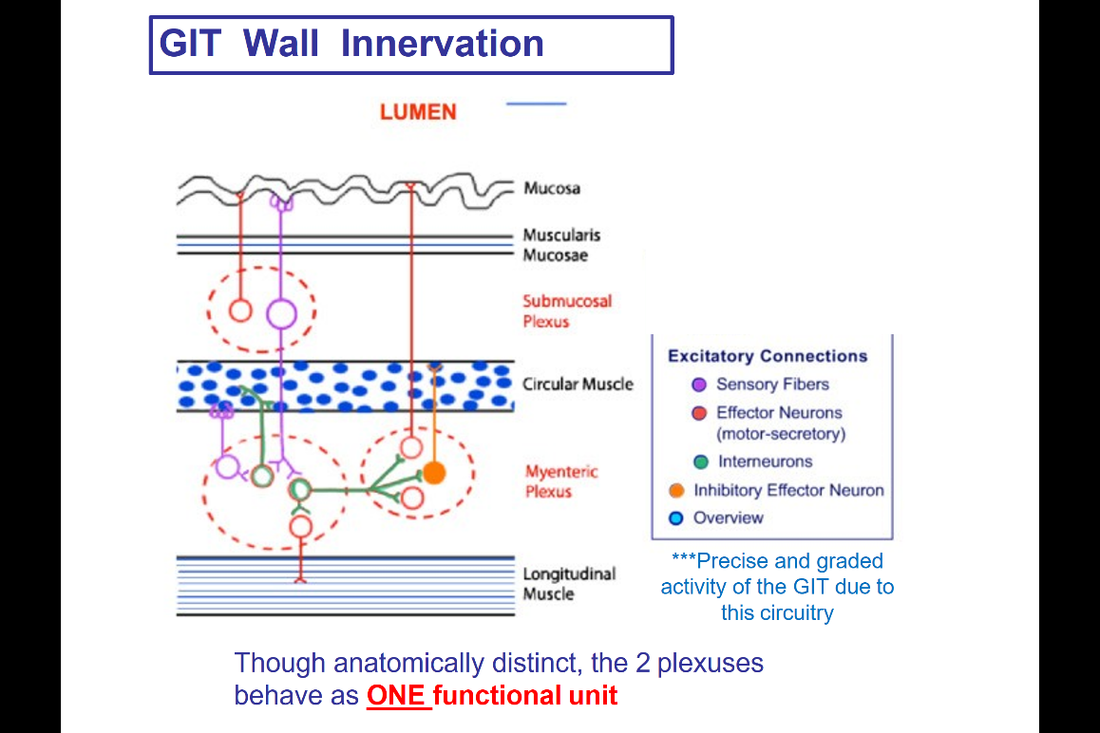
- Sensory fibers (purple) from the mucosa will be sensing the content of the gut → This then contact the interneuron, effector neuron that leads to the increase/ decrease of the secretion at the level at epithelia. Similarly, effector neuron affect the muscular layers of the cell, can have both excitory/inhibitory neuron.
- The joining is complex, and all can operate independently within the gut itself.

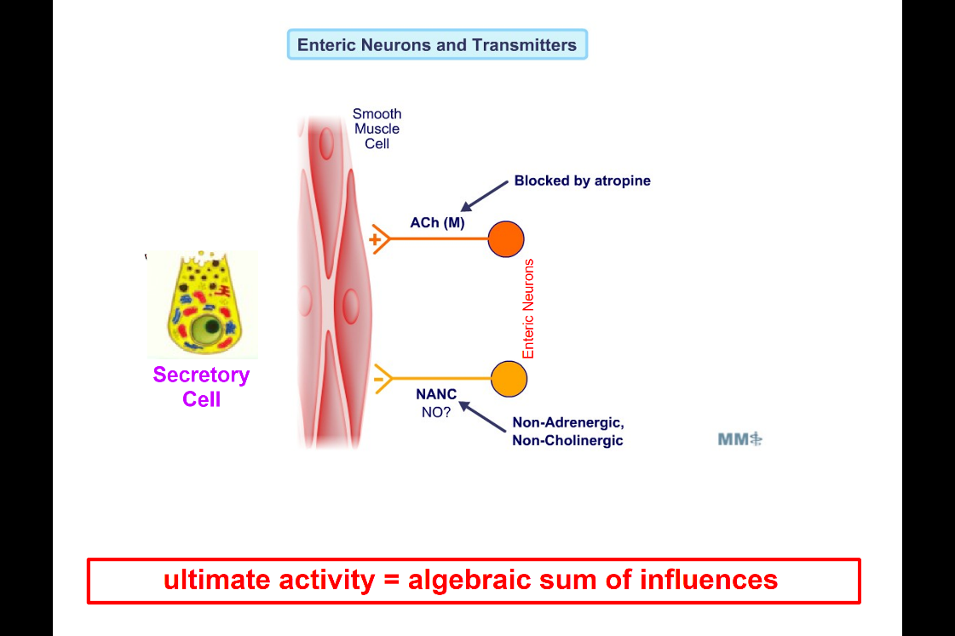

The transmitter within the enteric nervous system
- Effector neuron: excitory neuron + inhibitory neuron, these can affect either the muscular or secretory cells
- Excitory: use Acetylcholine as neuron transmitter and on muscle cell there is muscarinic receptor , these synapse will be block by atropine(antagonist)
- Inhibitory neurons, there is a variety of neuro transmitter release by the inhibitory neurons. We lump them as a group as “Non-Adrenergic, Non- Cholinergic fibers ” because they release nitroxide, ADP, peptides ….but the net effect is to inhibit the cells (muscle/secretory cells)
- Whatever happen at the cell will be the algebraic sum o the different content contact to it
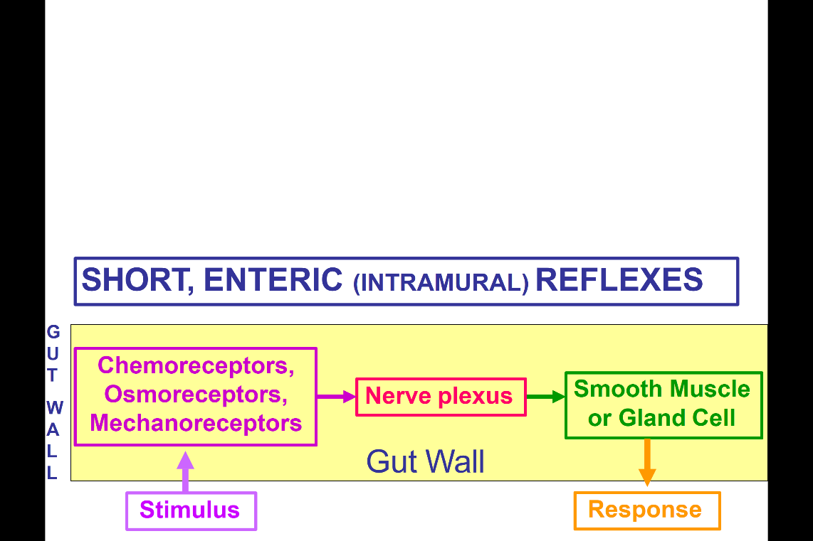

- Stimulus (can be stretch , high osmolality…)
- Sense by receptor in the gut wall (chemo, osmoreceptor is in the lumen epithelia layer but the mechanoreceptor is present in all the muscularies layers)
- Activate interneuron, plexus
- Activate/inhibit the smooth muscle/glandular cell
- Affect the response which can give a new stimulus
- So its all operate independently in GIT, we gonna call these short reflexes (because they all happen in GIT) can also say enteric reflexes, intramural reflexes (they all happen within the wall of GIT)
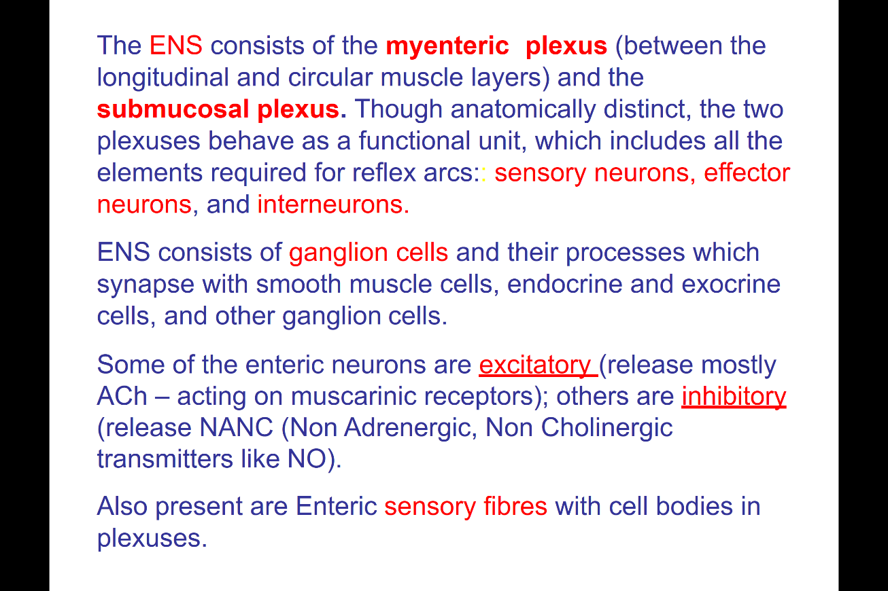
What’s a reflex = a reflex is a stimulus that generate a response

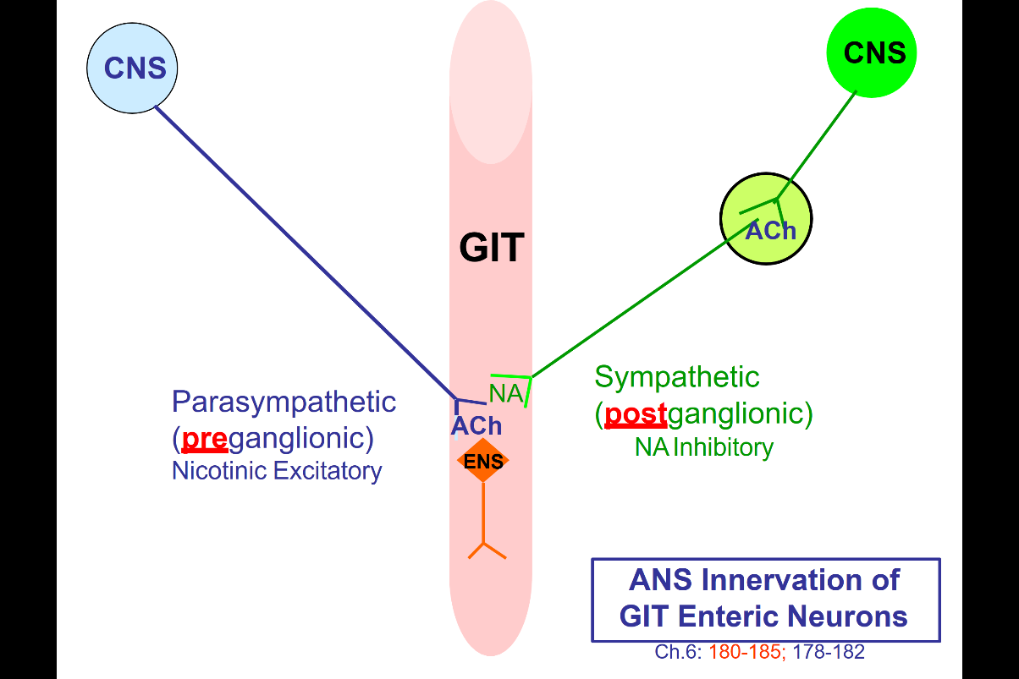

The enteric nervous can operate independently (don’t need input from cns), but CNS via autonomic nervous system can affect the GIT (through enteric nervous system)
- Autonomic nervous system is never going to send a signal directly to the muscle or the glandular cells ( always affect on enteric nervous system, which then effect on those cells ) The enteric nervous system is the one that do all the work within the walls of GIT, but the extrinsic signal will affect the enteric nervous system.
- Parasympathetic( preganglionic fibers) the preganglionic is going to come directly from the CNS enter the GIT.
- The transmitter is : Ach (activate the Ach – Nicotinic receptor)
- Excitory effect
- Sympathetic nervous system, ganglia located outside the nervous system
- The input from the CNS through postganglionic cells
- CNS (sympathetic output) ----- ganglia ----- GIT enteric nervous system ---
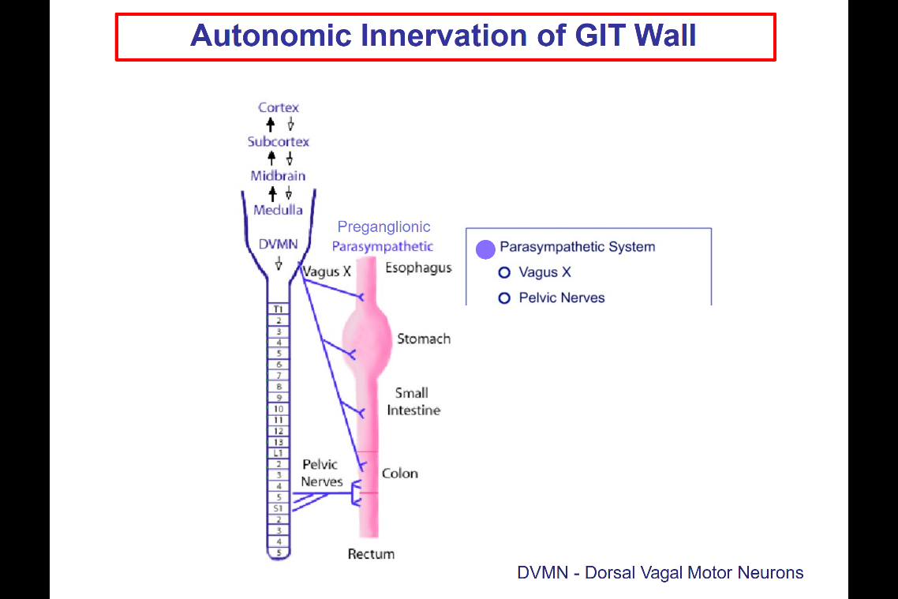
- The transmitter: norepinephrine

Parasympathetic:
- Originate : from the Cns at Medulla
- Dorsal vegal motor neuron in medulla
- Vagus nerve
- Effect most of the level of GIT
- So the vagus nerve is what will be interacting most if the GIT,
- except at the end of colon, rectum: the parasympathetic innervation is pelvic nerve

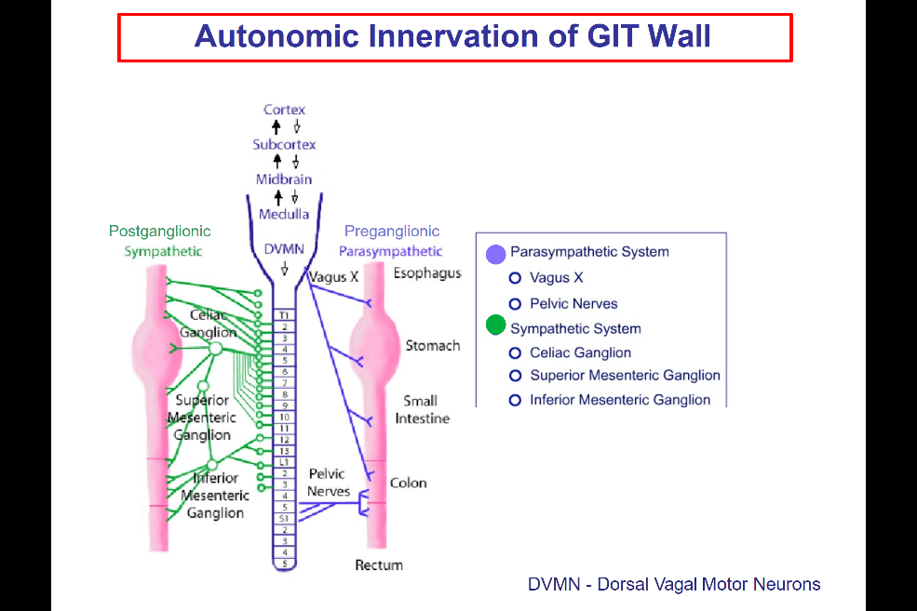
Postganglionic Sympathetic :
- no need to know the name but do know they are from post ganglionic and input to the GIT

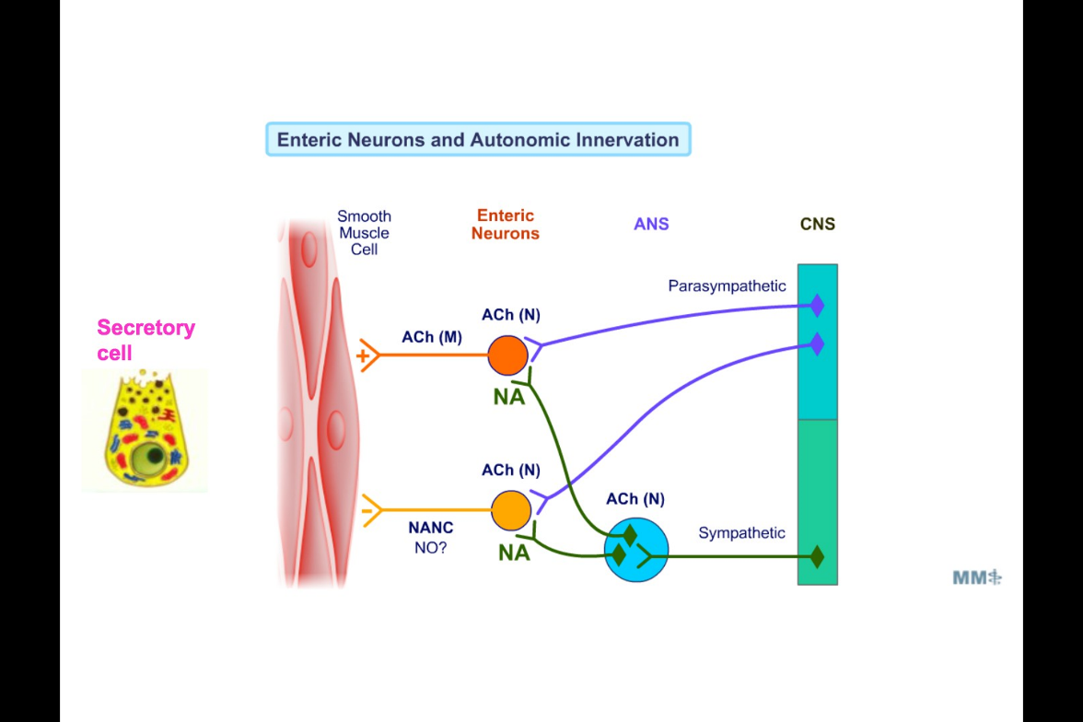
- out together
- Parasympathetic coming from vagus nerve in to GIT
- These fibers are excitory releasing Ach on to nicotinic Ach receptor at the level of enteric neuron (these will excite the enteric nervous system)
- Sympathetic nervous system (relay ganglion)
- Relax, Ach as a transmitter (in the bottom blue) to activate the NANC fiber but than lead to a second synapse that comes on the enteric neuron with NA transmitter
- Para excite the GIT, sympathetic inhibit (opposite to cardiac system) but rather than direct affect the muscular system, these affects via enteric system (excite excitory neuron or excite inhibitory neuron with para/sympathetic) (excite inhibitory ----will increase inhibition in the system)
- If excite inhibitory, decrease the excitory
- If inhibit inhibitor neuron, decrease the inhibition.
- Depend on the balance of excitory and inhibition.
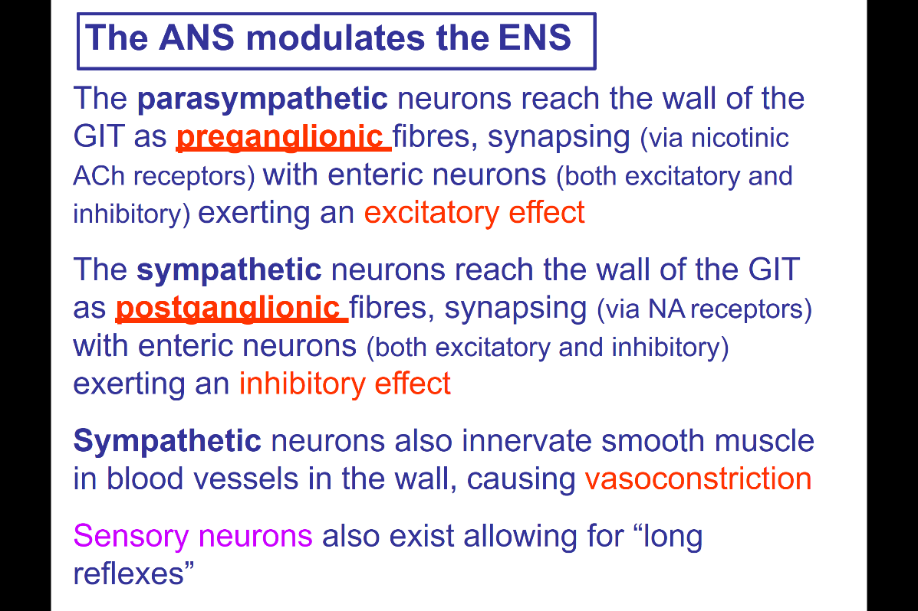
- This is a fine control along the length of GIT

Sensory can do both short and long reflex (talk about this in the future)

